Terraform Task

Create a VPC with public subnet, private subnet, route table & IGW by Module in terraform

**Name – Shashank Sharma**

**Note:**

Before performing this practical you should configure your system

Use following commands to configure the **awscli**

**Commands-**

Use command as root user;

* + sudo apt install awscli
  + aws configure –profile configs

(put your access key & secret access key)

* + ls -a
  + cd .aws
  + pwd (copy path & paste in DEV folder of main.tf -> module in module =source “/home/username/.aws/credentials” )

1. Firstly create 1 main folder called as vpc-module-tf (your folder name).

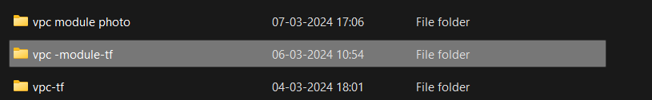

1. Create 2 sub-folder in main folder (module & resource).

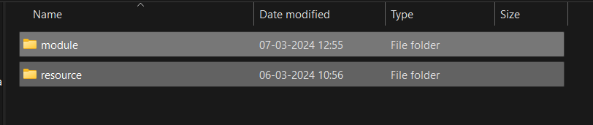

1. Create 3 sub-folder (dev, prod, test) in module folder.

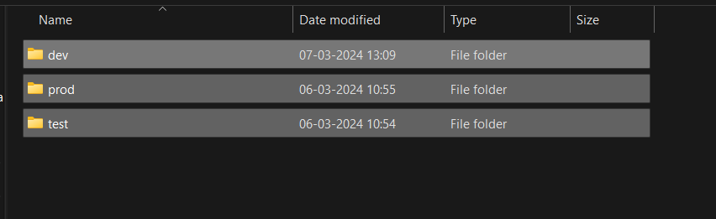

1. Create 1 sub-folder (vpc) in resource folder.

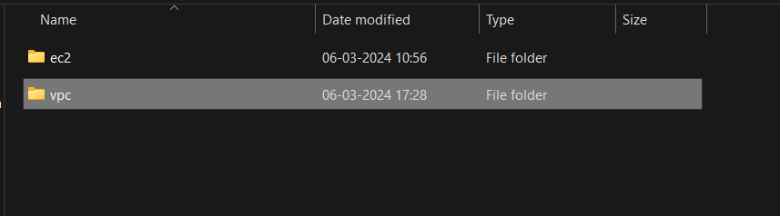

1. Open VS code & make files in DEV folder as will as VPC folder.
2. In DEV folder
3. Main.tf
4. Profile.tf
5. In VPC folder
6. Main.tf
7. Output.tf
8. Var.tf

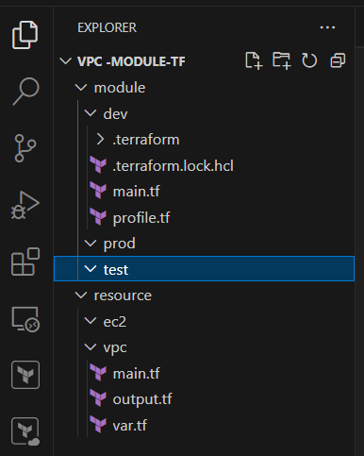

1. Write script in VPC main.tf

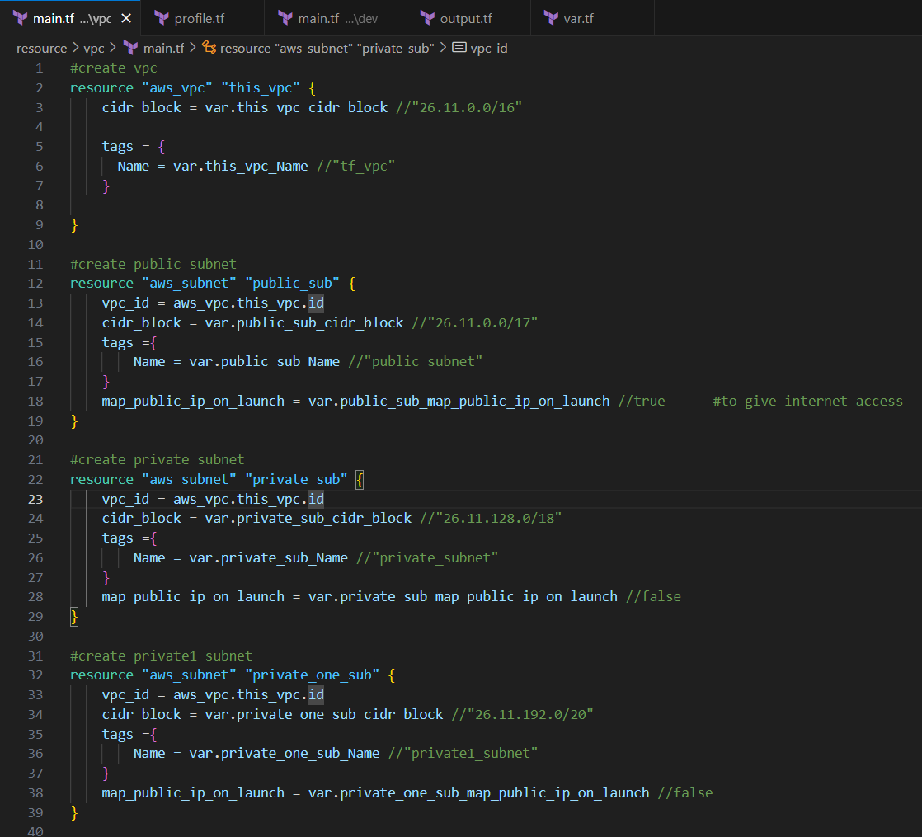

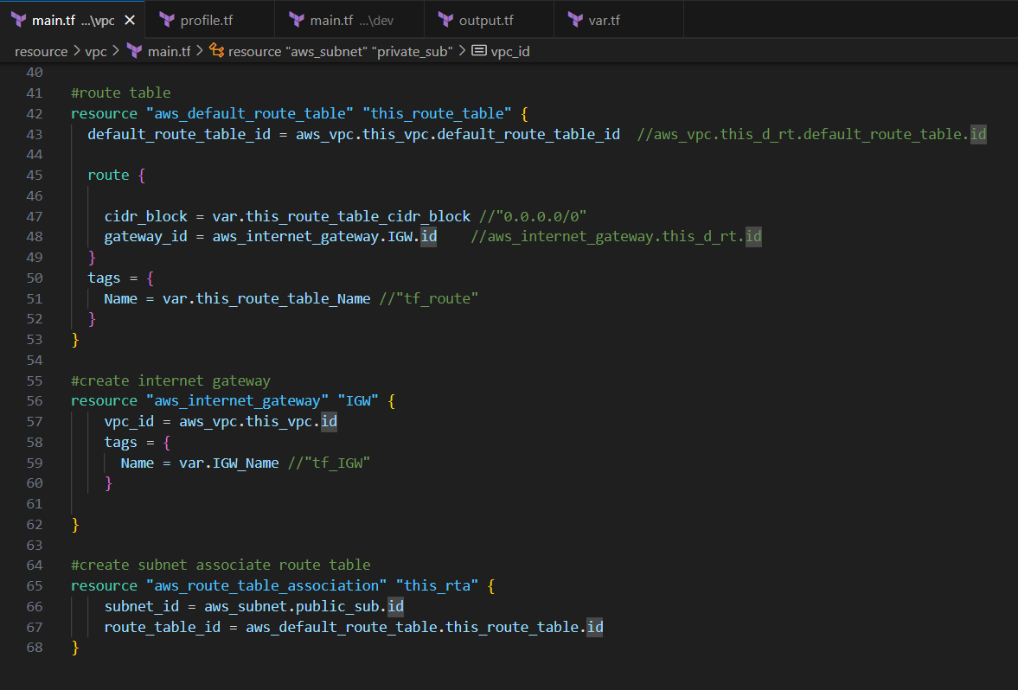

1. Write script in VPC var.tf.

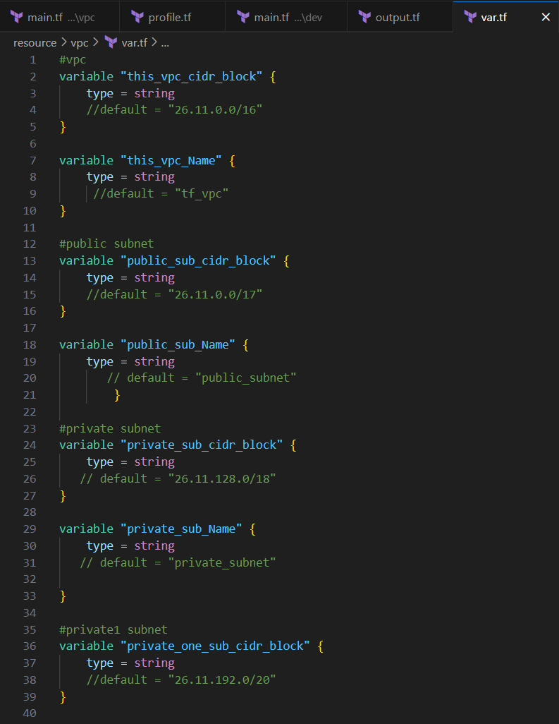

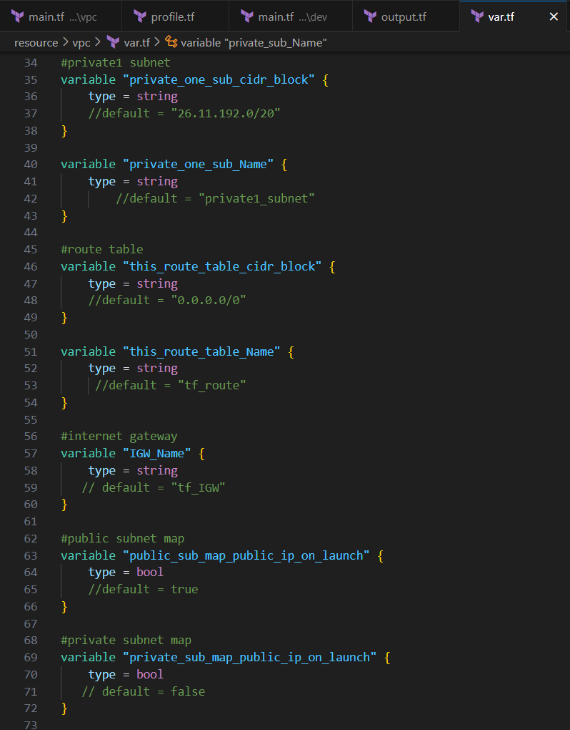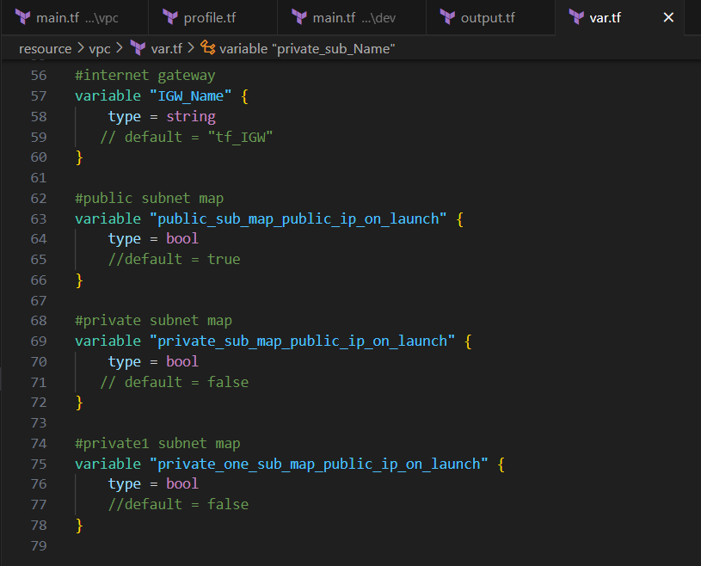

1. Write script in VPC output.tf

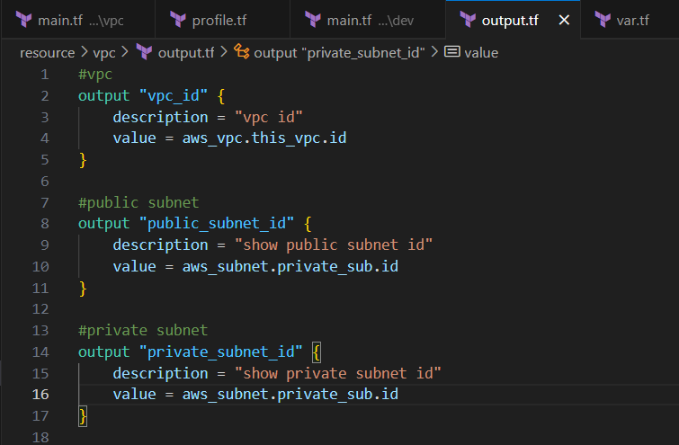

1. Write script in DEV profile.tf

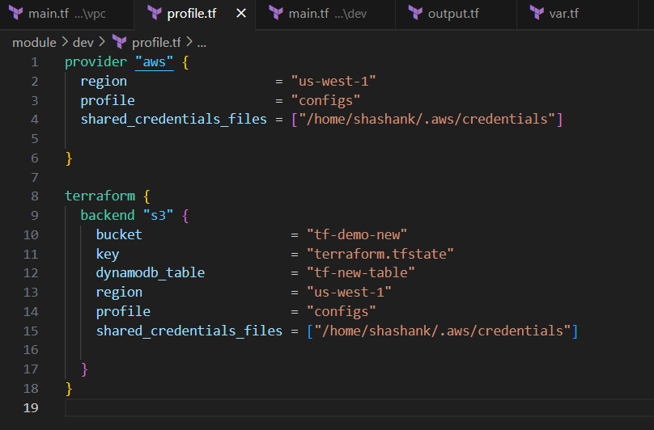

1. Write script in DEV main.tf .

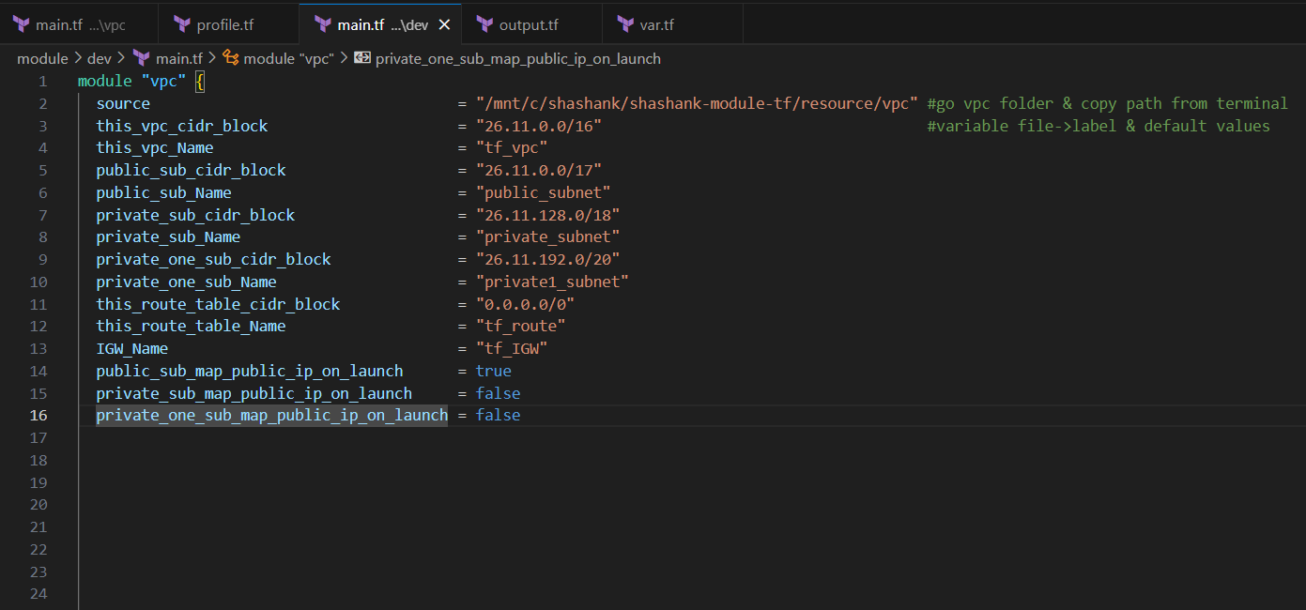

1. The final output is;

